使用Fabric GO Client网页APP访问区块链网络（3centos7服务器）

$GOPATH/src/github.com/hyperledger/fabric/3ArchGoChain #工作路径
systemctl restart docker;
docker stop $(docker ps -a -q);
docker rm $(docker ps -a -q);
docker network rm config_clustertest;
docker network rm config_5server;
docker volume prune;

删除包含某字符串的镜像：
docker rmi $(docker images | grep dev-peer | awk '{print $3}')

安装jq工具：
yum install epel-release;
yum list jq;
yum install jq;

※在orderer1生成公私钥和证书,存于crypto-config中
./bin/cryptogen generate --config=./config/crypto-config.yaml

※在orderer1为Org1和org2生成ccp文件
./crypto-config/ccp-generate.sh

※在orderer1创建通道创世区块channel1.tx（使用configtx.yaml）,然后将crypto-config和channel-artifacts两个文件夹及其内容，分别拷贝到两个peer服务器
export PATH=${PWD}/bin:$PATH;
export FABRIC_CFG_PATH=${PWD}/config;
./bin/configtxgen -profile ClusterOrgsApplicationGenesis -outputBlock ./channel-artifacts/channel1.tx -channelID channel1

※在Orderer1虚拟机上docker启动orderer服务：
docker-compose -f ./config/docker-compose-orderer1.yaml up -d

※在Orderer1虚拟机上激活通道并让Orderer1加入通道：
./bin/osnadmin channel join --channel-id channel1 --config-block ./channel-artifacts/channel1.tx -o 192.168.87.161:7053 \
--ca-file ./crypto-config/ordererOrganizations/example.com/orderers/orderer1.example.com/msp/tlscacerts/tlsca.example.com-cert.pem \
--client-cert ./crypto-config/ordererOrganizations/example.com/orderers/orderer1.example.com/tls/server.crt \
--client-key ./crypto-config/ordererOrganizations/example.com/orderers/orderer1.example.com/tls/server.key

※docker启动peer0.org1.example.com服务：
docker-compose -f ./config/docker-compose-peer0org1.yaml up -d

※Peer0.Org2虚拟机上docker启动peer：
docker-compose -f ./config/docker-compose-peer0org2.yaml up -d

※在虚拟机peer0.org1将peer0加入通道channel1（#使用路径下的core.yaml配置文件）
#将organization1加入通道channel1（#使用路径下的core.yaml配置文件）：
export FABRIC_CFG_PATH=${PWD}/config;
export CORE_PEER_TLS_ENABLED=true;
export CORE_PEER_LOCALMSPID="Org1MSP";
export CORE_PEER_TLS_ROOTCERT_FILE=${PWD}/crypto-config/peerOrganizations/org1.example.com/peers/peer0.org1.example.com/tls/ca.crt;
export CORE_PEER_MSPCONFIGPATH=${PWD}/crypto-config/peerOrganizations/org1.example.com/users/Admin@org1.example.com/msp;
export CORE_PEER_ADDRESS=192.168.87.162:7051;
./bin/peer channel join -b ./channel-artifacts/channel1.tx -o 192.168.87.161:7050 --ordererTLSHostnameOverride orderer.example.com

※在虚拟机peer0.org2将peer0加入通道channel1（#使用路径下的core.yaml配置文件）
#将organization1加入通道channel1（#使用路径下的core.yaml配置文件）：
export FABRIC_CFG_PATH=${PWD}/config;
export CORE_PEER_TLS_ENABLED=true;
export CORE_PEER_LOCALMSPID="Org2MSP";
export CORE_PEER_TLS_ROOTCERT_FILE=${PWD}/crypto-config/peerOrganizations/org2.example.com/peers/peer0.org2.example.com/tls/ca.crt;
export CORE_PEER_MSPCONFIGPATH=${PWD}/crypto-config/peerOrganizations/org2.example.com/users/Admin@org2.example.com/msp;
export CORE_PEER_ADDRESS=192.168.87.163:7051;
./bin/peer channel join -b ./channel-artifacts/channel1.tx -o 192.168.87.161:7050 --ordererTLSHostnameOverride orderer.example.com

※在通道channel1上为Org1MSP设置锚节点：将peer0.org1设置为锚节点
export FABRIC_CFG_PATH=${PWD}/config;
export CORE_PEER_TLS_ENABLED=true;
export CORE_PEER_LOCALMSPID="Org1MSP";
export CORE_PEER_TLS_ROOTCERT_FILE=${PWD}/crypto-config/peerOrganizations/org1.example.com/peers/peer0.org1.example.com/tls/ca.crt;
export CORE_PEER_MSPCONFIGPATH=${PWD}/crypto-config/peerOrganizations/org1.example.com/users/Admin@org1.example.com/msp;
export CORE_PEER_ADDRESS=192.168.87.162:7051;
./bin/peer channel fetch config config_block.pb -o 192.168.87.161:7050 --ordererTLSHostnameOverride orderer1.example.com -c channel1 --tls --cafile \
${PWD}/crypto-config/ordererOrganizations/example.com/orderers/orderer1.example.com/msp/tlscacerts/tlsca.example.com-cert.pem

./bin/configtxlator proto_decode --input config_block.pb --type common.Block | jq .data.data[0].payload.data.config >Org1MSPconfig.json;
jq '.channel_group.groups.Application.groups.Org1MSP.values += {"AnchorPeers":{"mod_policy": "Admins","value":{"anchor_peers": [{"host": "192.168.87.162","port": 7051}]},"version": "0"}}' Org1MSPconfig.json >Org1MSPmodified_config.json; #修改配置文件：加入锚节点信息;jq是Linux下面把文本字符串格式化成json格式的工具
./bin/configtxlator proto_encode --input Org1MSPconfig.json --type common.Config >original_config.pb;
./bin/configtxlator proto_encode --input Org1MSPmodified_config.json --type common.Config >modified_config.pb;
./bin/configtxlator compute_update --channel_id channel1 --original original_config.pb --updated modified_config.pb >config_update.pb;
./bin/configtxlator proto_decode --input config_update.pb --type common.ConfigUpdate >config_update.json;
echo '{"payload":{"header":{"channel_header":{"channel_id":"channel1", "type":2}},"data":{"config_update":'$(cat config_update.json)'}}}' | jq . >config_update_in_envelope.json; #jq把文本字符串格式化成json;cat将几个文件合并为一个文件
./bin/configtxlator proto_encode --input config_update_in_envelope.json --type common.Envelope >Org1MSPanchors.tx

#向orderer发送锚节点配置文件Org1MSPanchors.tx
./bin/peer channel update -o 192.168.87.161:7050 --ordererTLSHostnameOverride orderer1.example.com -c channel1 -f Org1MSPanchors.tx --tls --cafile \
${PWD}/crypto-config/ordererOrganizations/example.com/orderers/orderer1.example.com/msp/tlscacerts/tlsca.example.com-cert.pem

※在通道channel1上为Org2MSP设置锚节点（Anchor peer set for org 'Org2MSP' on channel 'channel1'）
export FABRIC_CFG_PATH=${PWD}/config;
export CORE_PEER_TLS_ENABLED=true;
export CORE_PEER_LOCALMSPID="Org2MSP";
export CORE_PEER_TLS_ROOTCERT_FILE=${PWD}/crypto-config/peerOrganizations/org2.example.com/peers/peer0.org2.example.com/tls/ca.crt;
export CORE_PEER_MSPCONFIGPATH=${PWD}/crypto-config/peerOrganizations/org2.example.com/users/Admin@org2.example.com/msp;
export CORE_PEER_ADDRESS=192.168.87.163:7051;
./bin/peer channel fetch config config_block.pb -o 192.168.87.161:7050 --ordererTLSHostnameOverride orderer1.example.com -c channel1 --tls --cafile \
${PWD}/crypto-config/ordererOrganizations/example.com/orderers/orderer1.example.com/msp/tlscacerts/tlsca.example.com-cert.pem

./bin/configtxlator proto_decode --input config_block.pb --type common.Block | jq .data.data[0].payload.data.config >Org2MSPconfig.json;
jq '.channel_group.groups.Application.groups.Org2MSP.values += {"AnchorPeers":{"mod_policy": "Admins","value":{"anchor_peers": [{"host": "192.168.87.163","port": 7051}]},"version": "0"}}' Org2MSPconfig.json >Org2MSPmodified_config.json; #修改配置文件：加入锚节点信息
./bin/configtxlator proto_encode --input Org2MSPconfig.json --type common.Config >original_config.pb;
./bin/configtxlator proto_encode --input Org2MSPmodified_config.json --type common.Config >modified_config.pb;
./bin/configtxlator compute_update --channel_id channel1 --original original_config.pb --updated modified_config.pb >config_update.pb;
./bin/configtxlator proto_decode --input config_update.pb --type common.ConfigUpdate >config_update.json;
echo '{"payload":{"header":{"channel_header":{"channel_id":"channel1", "type":2}},"data":{"config_update":'$(cat config_update.json)'}}}' | jq . >config_update_in_envelope.json; #jq把文本字符串格式化成json;cat将几个文件合并为一个文件
./bin/configtxlator proto_encode --input config_update_in_envelope.json --type common.Envelope >Org2MSPanchors.tx

#向orderer发送锚节点配置文件Org2MSPanchors.tx
./bin/peer channel update -o 192.168.87.161:7050 --ordererTLSHostnameOverride orderer1.example.com -c channel1 -f Org2MSPanchors.tx --tls --cafile \
${PWD}/crypto-config/ordererOrganizations/example.com/orderers/orderer1.example.com/msp/tlscacerts/tlsca.example.com-cert.pem

※在peer0.org1\peer0.org2分别打包chaincode（链码），包名archcc.tar.gz，链码名archcc：
./bin/peer lifecycle chaincode package archcc.tar.gz -p ./chaincode --label archcc

※在peer0.org1\peer0.org2上分别安装链码：
export CORE_PEER_TLS_ENABLED=true;
export CORE_PEER_LOCALMSPID="Org1MSP";
export CORE_PEER_TLS_ROOTCERT_FILE=${PWD}/crypto-config/peerOrganizations/org1.example.com/peers/peer0.org1.example.com/tls/ca.crt;
export CORE_PEER_MSPCONFIGPATH=${PWD}/crypto-config/peerOrganizations/org1.example.com/users/Admin@org1.example.com/msp;
export CORE_PEER_ADDRESS=192.168.87.162:7051;
./bin/peer lifecycle chaincode install archcc.tar.gz

export CORE_PEER_TLS_ENABLED=true;
export CORE_PEER_LOCALMSPID="Org2MSP";
export CORE_PEER_TLS_ROOTCERT_FILE=${PWD}/crypto-config/peerOrganizations/org2.example.com/peers/peer0.org2.example.com/tls/ca.crt;
export CORE_PEER_MSPCONFIGPATH=${PWD}/crypto-config/peerOrganizations/org2.example.com/users/Admin@org2.example.com/msp;
export CORE_PEER_ADDRESS=192.168.87.163:7051;
./bin/peer lifecycle chaincode install archcc.tar.gz

※在peer0.org1\peer0.org2上分别代表org1\org2组织approve 链码定义（defination）
export CORE_PEER_TLS_ENABLED=true;
export CORE_PEER_LOCALMSPID="Org1MSP";
export CORE_PEER_TLS_ROOTCERT_FILE=${PWD}/crypto-config/peerOrganizations/org1.example.com/peers/peer0.org1.example.com/tls/ca.crt;
export CORE_PEER_MSPCONFIGPATH=${PWD}/crypto-config/peerOrganizations/org1.example.com/users/Admin@org1.example.com/msp;
export CORE_PEER_ADDRESS=192.168.87.162:7051;
./bin/peer lifecycle chaincode approveformyorg -o 192.168.87.161:7050 --ordererTLSHostnameOverride orderer1.example.com --tls \
--cafile ${PWD}/crypto-config/ordererOrganizations/example.com/orderers/orderer1.example.com/msp/tlscacerts/tlsca.example.com-cert.pem \
--channelID channel1 --name archcc --version 1.0 --package-id archcc:a233cd0783af0e479284ae5edbde3213d1732eda6c7234f2210c1b6ede61a3b8 --sequence 1

export CORE_PEER_TLS_ENABLED=true;
export CORE_PEER_LOCALMSPID="Org2MSP";
export CORE_PEER_TLS_ROOTCERT_FILE=${PWD}/crypto-config/peerOrganizations/org2.example.com/peers/peer0.org2.example.com/tls/ca.crt;
export CORE_PEER_MSPCONFIGPATH=${PWD}/crypto-config/peerOrganizations/org2.example.com/users/Admin@org2.example.com/msp;
export CORE_PEER_ADDRESS=192.168.87.163:7051;
./bin/peer lifecycle chaincode approveformyorg -o 192.168.87.161:7050 --ordererTLSHostnameOverride orderer1.example.com --tls \
--cafile ${PWD}/crypto-config/ordererOrganizations/example.com/orderers/orderer1.example.com/msp/tlscacerts/tlsca.example.com-cert.pem \
--channelID channel1 --name archcc --version 1.0 --package-id archcc:a233cd0783af0e479284ae5edbde3213d1732eda6c7234f2210c1b6ede61a3b8 --sequence 1

※在peer0.org1节点代表org1和org2组织向通道提交链码定义（defination）
./bin/peer lifecycle chaincode commit -o 192.168.87.161:7050 --ordererTLSHostnameOverride orderer1.example.com --tls \
--cafile ${PWD}/crypto-config/ordererOrganizations/example.com/orderers/orderer1.example.com/msp/tlscacerts/tlsca.example.com-cert.pem \
--channelID channel1 --name archcc \
--peerAddresses 192.168.87.162:7051 \
--tlsRootCertFiles ${PWD}/crypto-config/peerOrganizations/org1.example.com/peers/peer0.org1.example.com/tls/ca.crt \
--peerAddresses 192.168.87.163:7051 \
--tlsRootCertFiles ${PWD}/crypto-config/peerOrganizations/org2.example.com/peers/peer0.org2.example.com/tls/ca.crt \
--version 1.0 --sequence 1

※从节点peer0.org2调用链码上的函数InitLedger（档案件对应的摘要-链码）
export CORE_PEER_TLS_ENABLED=true #以下为设置环境变量为org2的，即在org2上调用链码
export CORE_PEER_LOCALMSPID="Org2MSP"
export CORE_PEER_TLS_ROOTCERT_FILE=${PWD}/crypto-config/peerOrganizations/org2.example.com/peers/peer0.org2.example.com/tls/ca.crt
export CORE_PEER_MSPCONFIGPATH=${PWD}/crypto-config/peerOrganizations/org2.example.com/users/Admin@org2.example.com/msp
export CORE_PEER_ADDRESS=192.168.87.163:7051
./bin/peer chaincode invoke -o 192.168.87.161:7050 --ordererTLSHostnameOverride orderer1.example.com --tls \
--cafile "${PWD}/crypto-config/ordererOrganizations/example.com/orderers/orderer1.example.com/msp/tlscacerts/tlsca.example.com-cert.pem" -C channel1 -n archcc \
--peerAddresses 192.168.87.162:7051 --tlsRootCertFiles "${PWD}/crypto-config/peerOrganizations/org1.example.com/peers/peer0.org1.example.com/tls/ca.crt" \
--peerAddresses 192.168.87.163:7051 --tlsRootCertFiles "${PWD}/crypto-config/peerOrganizations/org2.example.com/peers/peer0.org2.example.com/tls/ca.crt" \
-c '{"function":"InitLedger","Args":[]}'

_________________IMPORtANTS!!!_________________

修改静态IP地址
vi /etc/sysconfig/network-scripts/ifcfg-ens33
其中bootproto=static
onboot=yes
IPADDR=192.168.87.164

※在peer0Org3中为自己生成公私钥和证书，存于crypto-config中（使用配置好的org3-crypto.yaml，其中具体内容在附件中）
./bin/cryptogen generate --config=./config/org3-crypto.yaml

※在peer0Org3为自己生成ccp文件（使用配置好的ccp-generate.sh，其中具体内容在附件中）
./crypto-config/ccp-generate.sh

※Generating Org3 organization definition（使用配置好的 configtx.yaml，其中具体内容在附件中）
export FABRIC_CFG_PATH=${PWD}/config;
#Prints the definition of an organization as JSON. (useful for adding an org to a channel manually)
./bin/configtxgen -printOrg Org3MSP > ./crypto-config/peerOrganizations/org3.example.com/org3.json

※docker启动peer0.org3.example.com服务（带couchdb的启动，docker-compose-peer0org3.yaml内容类似docker-compose-peer0org1.yaml）：
docker-compose -f ./config/docker-compose-peer0org3.yaml up -d
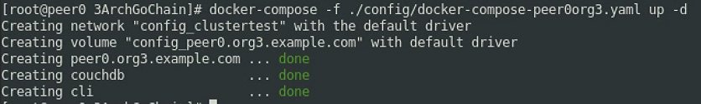

※Generating and submitting config tx to add Org3----Fetch the config for the channel, writing it to config.json
#注意：是在peer0.org1上执行此步（需先将org3.json从peer0.org3上拷贝到peer0.org1的指定位置）
export CORE_PEER_TLS_ENABLED=true;
export CORE_PEER_LOCALMSPID="Org1MSP";
export CORE_PEER_TLS_ROOTCERT_FILE=${PWD}/crypto-config/peerOrganizations/org1.example.com/peers/peer0.org1.example.com/tls/ca.crt;
export CORE_PEER_MSPCONFIGPATH=${PWD}/crypto-config/peerOrganizations/org1.example.com/users/Admin@org1.example.com/msp;
export CORE_PEER_ADDRESS=192.168.87.162:7051;
./bin/peer channel fetch config config_block.pb -o 192.168.87.161:7050 --ordererTLSHostnameOverride orderer1.example.com -c channel1 --tls \
--cafile "${PWD}/crypto-config/ordererOrganizations/example.com/orderers/orderer1.example.com/msp/tlscacerts/tlsca.example.com-cert.pem"
./bin/configtxlator proto_decode --input config_block.pb --type common.Block | jq .data.data[0].payload.data.config >"config.json" #Decoding config block to JSON and isolating config to config.json。

# Modify the configuration to append the new org
jq -s '.[0] * {"channel_group":{"groups":{"Application":{"groups": {"Org3MSP":.[1]}}}}}' config.json ./crypto-config/peerOrganizations/org3.example.com/org3.json > modified_config.json

# Compute a config update, based on the differences between config.json and modified_config.json, write it as a transaction to org3_update_in_envelope.pb
./bin/configtxlator proto_encode --input "config.json" --type common.Config >original_config.pb;
./bin/configtxlator proto_encode --input "modified_config.json" --type common.Config >modified_config.pb;
./bin/configtxlator compute_update --channel_id "channel1" --original original_config.pb --updated modified_config.pb >config_update.pb;
./bin/configtxlator proto_decode --input config_update.pb --type common.ConfigUpdate >config_update.json;
echo '{"payload":{"header":{"channel_header":{"channel_id":"'channel1'", "type":2}},"data":{"config_update":'$(cat config_update.json)'}}}' | jq . >config_update_in_envelope.json;
./bin/configtxlator proto_encode --input config_update_in_envelope.json --type common.Envelope >"org3_update_in_envelope.pb";

※Signing config transaction（注意：在peer0.org1上执行此步）
export CORE_PEER_TLS_ENABLED=true;
export CORE_PEER_LOCALMSPID="Org1MSP";
export CORE_PEER_TLS_ROOTCERT_FILE=${PWD}/crypto-config/peerOrganizations/org1.example.com/peers/peer0.org1.example.com/tls/ca.crt;
export CORE_PEER_MSPCONFIGPATH=${PWD}/crypto-config/peerOrganizations/org1.example.com/users/Admin@org1.example.com/msp;
export CORE_PEER_ADDRESS=192.168.87.162:7051;
./bin/peer channel signconfigtx -f "org3_update_in_envelope.pb"
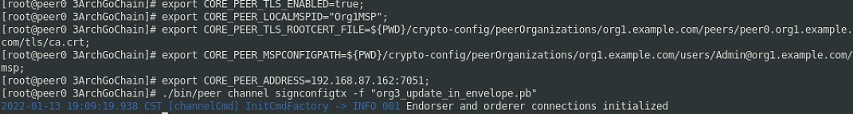

※Submitting transaction from a different peer (peer0.org2) which also signs it
#注意：在peer0.org2上执行此步（需先将org3_update_in_envelope.pb从peer0.org1上拷贝到peer0.org2上）
export CORE_PEER_TLS_ENABLED=true
export CORE_PEER_LOCALMSPID="Org2MSP"
export CORE_PEER_TLS_ROOTCERT_FILE=${PWD}/crypto-config/peerOrganizations/org2.example.com/peers/peer0.org2.example.com/tls/ca.crt
export CORE_PEER_MSPCONFIGPATH=${PWD}/crypto-config/peerOrganizations/org2.example.com/users/Admin@org2.example.com/msp
export CORE_PEER_ADDRESS=192.168.87.163:7051
./bin/peer channel update -f org3_update_in_envelope.pb -c channel1 -o 192.168.87.161:7050 --ordererTLSHostnameOverride orderer1.example.com --tls \
--cafile ${PWD}/crypto-config/ordererOrganizations/example.com/orderers/orderer1.example.com/msp/tlscacerts/tlsca.example.com-cert.pem
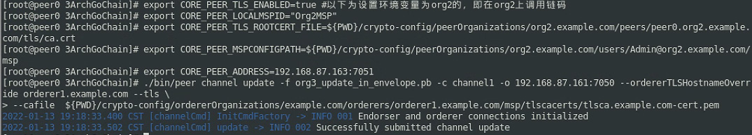

※Joining Org3 peers to network（注意：此步在peer0.org3上执行）
#Fetching channel config block from orderer...
export CORE_PEER_TLS_ENABLED=true
export CORE_PEER_LOCALMSPID="Org3MSP"
export CORE_PEER_TLS_ROOTCERT_FILE=${PWD}/crypto-config/peerOrganizations/org3.example.com/peers/peer0.org3.example.com/tls/ca.crt
export CORE_PEER_MSPCONFIGPATH=${PWD}/crypto-config/peerOrganizations/org3.example.com/users/Admin@org3.example.com/msp
export CORE_PEER_ADDRESS=192.168.87.164:7051
#获取通道区块（区块序号为0），区块信息写入文件channel1.block
./bin/peer channel fetch 0 channel1.block -o 192.168.87.161:7050 --ordererTLSHostnameOverride orderer1.example.com -c channel1 --tls \
--cafile ${PWD}/crypto-config/ordererOrganizations/example.com/orderers/orderer1.example.com/msp/tlscacerts/tlsca.example.com-cert.pem
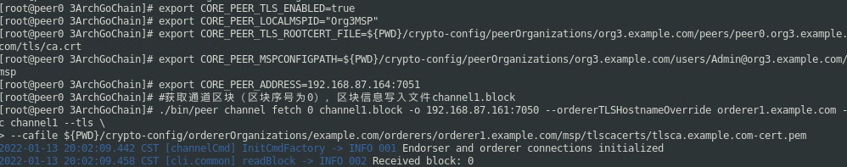

※在虚拟机peer0.org3将peer0加入通道channel1（#使用路径下的core.yaml配置文件）
export FABRIC_CFG_PATH=${PWD}/config;
export CORE_PEER_TLS_ENABLED=true;
export CORE_PEER_LOCALMSPID="Org3MSP";
export CORE_PEER_TLS_ROOTCERT_FILE=${PWD}/crypto-config/peerOrganizations/org3.example.com/peers/peer0.org3.example.com/tls/ca.crt;
export CORE_PEER_MSPCONFIGPATH=${PWD}/crypto-config/peerOrganizations/org3.example.com/users/Admin@org3.example.com/msp;
export CORE_PEER_ADDRESS=192.168.87.164:7051;
./bin/peer channel join -b ./channel-artifacts/channel1.block -o 192.168.87.161:7050 --ordererTLSHostnameOverride orderer1.example.com

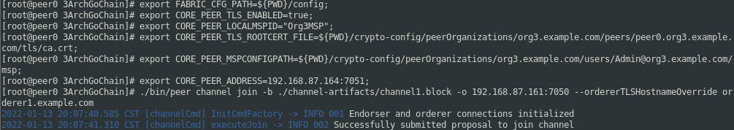

※在通道channel1上为Org3MSP设置锚节点：将peer0.org3设置为锚节点
export FABRIC_CFG_PATH=${PWD}/config;
export CORE_PEER_TLS_ENABLED=true;
export CORE_PEER_LOCALMSPID="Org3MSP";
export CORE_PEER_TLS_ROOTCERT_FILE=${PWD}/crypto-config/peerOrganizations/org3.example.com/peers/peer0.org3.example.com/tls/ca.crt;
export CORE_PEER_MSPCONFIGPATH=${PWD}/crypto-config/peerOrganizations/org3.example.com/users/Admin@org3.example.com/msp;
export CORE_PEER_ADDRESS=192.168.87.164:7051;
./bin/peer channel fetch config config_block.pb -o 192.168.87.161:7050 --ordererTLSHostnameOverride orderer1.example.com -c channel1 --tls --cafile \
${PWD}/crypto-config/ordererOrganizations/example.com/orderers/orderer1.example.com/msp/tlscacerts/tlsca.example.com-cert.pem

./bin/configtxlator proto_decode --input config_block.pb --type common.Block | jq .data.data[0].payload.data.config >Org3MSPconfig.json;
jq '.channel_group.groups.Application.groups.Org3MSP.values += {"AnchorPeers":{"mod_policy": "Admins","value":{"anchor_peers": [{"host": "192.168.87.164","port": 7051}]},"version": "0"}}' Org3MSPconfig.json >Org3MSPmodified_config.json; #修改配置文件：加入锚节点信息;jq是Linux下面把文本字符串格式化成json格式的工具
./bin/configtxlator proto_encode --input Org3MSPconfig.json --type common.Config >original_config.pb;
./bin/configtxlator proto_encode --input Org3MSPmodified_config.json --type common.Config >modified_config.pb;
./bin/configtxlator compute_update --channel_id channel1 --original original_config.pb --updated modified_config.pb >config_update.pb;
./bin/configtxlator proto_decode --input config_update.pb --type common.ConfigUpdate >config_update.json;
echo '{"payload":{"header":{"channel_header":{"channel_id":"channel1", "type":2}},"data":{"config_update":'$(cat config_update.json)'}}}' | jq . >config_update_in_envelope.json; #jq把文本字符串格式化成json;cat将几个文件合并为一个文件
./bin/configtxlator proto_encode --input config_update_in_envelope.json --type common.Envelope >Org3MSPanchors.tx

#向orderer发送锚节点配置文件Org3MSPanchors.tx
./bin/peer channel update -o 192.168.87.161:7050 --ordererTLSHostnameOverride orderer1.example.com -c channel1 -f Org3MSPanchors.tx --tls --cafile \
${PWD}/crypto-config/ordererOrganizations/example.com/orderers/orderer1.example.com/msp/tlscacerts/tlsca.example.com-cert.pem
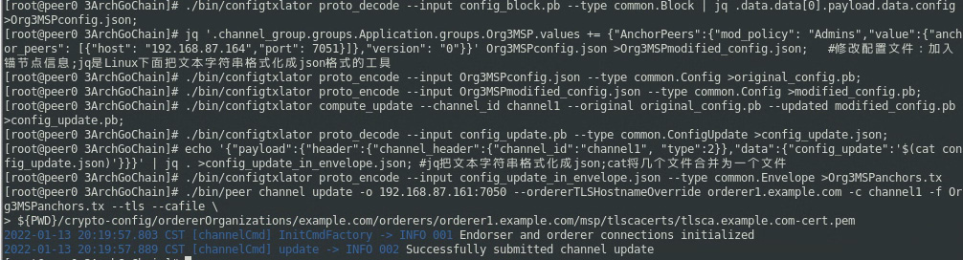

※在peer0.org3分别打包chaincode（链码），包名archcc.tar.gz，链码名archcc：
./bin/peer lifecycle chaincode package archcc.tar.gz -p ./chaincode --label archcc

※在peer0.org3上分别安装链码：
export CORE_PEER_TLS_ENABLED=true;
export CORE_PEER_LOCALMSPID="Org3MSP";
export CORE_PEER_TLS_ROOTCERT_FILE=${PWD}/crypto-config/peerOrganizations/org3.example.com/peers/peer0.org3.example.com/tls/ca.crt;
export CORE_PEER_MSPCONFIGPATH=${PWD}/crypto-config/peerOrganizations/org3.example.com/users/Admin@org3.example.com/msp;
export CORE_PEER_ADDRESS=192.168.87.164:7051;
./bin/peer lifecycle chaincode install archcc.tar.gz
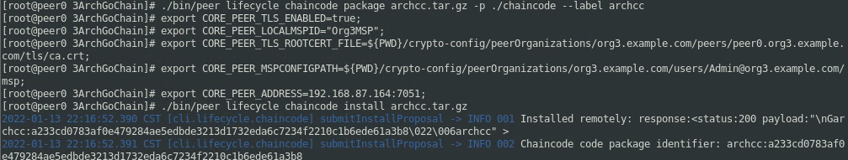

※在peer0.0rg3上查询channel ledger（账本）
./bin/peer chaincode invoke -o 192.168.87.161:7050 --ordererTLSHostnameOverride orderer1.example.com --tls \
--cafile "${PWD}/crypto-config/ordererOrganizations/example.com/orderers/orderer1.example.com/msp/tlscacerts/tlsca.example.com-cert.pem" -C channel1 -n archcc \
--peerAddresses 192.168.87.162:7051 --tlsRootCertFiles "${PWD}/crypto-config/peerOrganizations/org1.example.com/peers/peer0.org1.example.com/tls/ca.crt" \
--peerAddresses 192.168.87.163:7051 --tlsRootCertFiles "${PWD}/crypto-config/peerOrganizations/org2.example.com/peers/peer0.org2.example.com/tls/ca.crt" \
-c '{"Args":["GetAllAssets"]}'
#注意：没有approve链码的org的节点peer信息不能作为参数--peerAddresses
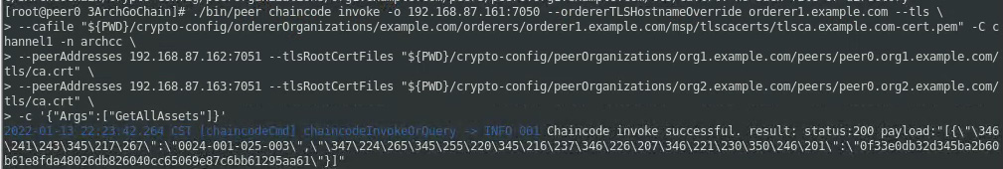

※在peer0.0rg3上查询channel ledger（调用参数中连接一个chaincode-approved peer）

./bin/peer chaincode invoke -o 192.168.87.161:7050 --ordererTLSHostnameOverride orderer1.example.com --tls \
--cafile "${PWD}/crypto-config/ordererOrganizations/example.com/orderers/orderer1.example.com/msp/tlscacerts/tlsca.example.com-cert.pem" -C channel1 -n archcc \
--peerAddresses 192.168.87.163:7051 --tlsRootCertFiles "${PWD}/crypto-config/peerOrganizations/org2.example.com/peers/peer0.org2.example.com/tls/ca.crt" \
-c '{"Args":["GetAllAssets"]}'

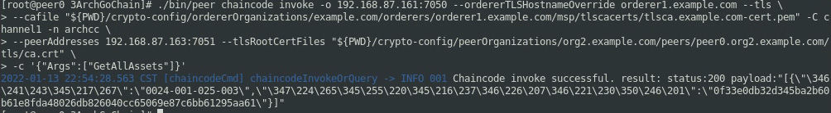

./bin/peer chaincode invoke -o 192.168.87.161:7050 --ordererTLSHostnameOverride orderer1.example.com --tls \
--cafile "${PWD}/crypto-config/ordererOrganizations/example.com/orderers/orderer1.example.com/msp/tlscacerts/tlsca.example.com-cert.pem" -C channel1 -n archcc \
-c '{"Args":["GetAllAssets"]}'
结果：出错---Error: endorsement failure during invoke. response: status:500 message:"make sure the chaincode archcc has been successfully defined on channel channel1 and try again: chaincode definition for 'archcc' at sequence 1 on channel 'channel1' has not yet been approved by this org" 。意思就是说出错原因有两个：1、channel1上的链码archcc可能没有成功定义；2、本ORG（即org3）未参与approve链码的定义，所以此ORG内所有PEER都无法做背书节点（查询链码时为自己背书）。
结论：查询链码时，必须有至少一个曾经approve过链码定义的peer做信信用背书。

查询链码ID：./bin/peer lifecycle chaincode queryinstalled

查询committed状态命令：./bin/peer lifecycle chaincode querycommitted --channelID channel1 --name archcc
发现：approval中Org3MSP为false。
查询区块信息./bin/peer channel getinfo -c channel1

